How to use EC2

When any app run on any port, just tap http:// ‘public ip’:’port’ on your local browser

1. Download any key-pair(.pem) on google drive, and remember its path
2. Open your terminal(Mac), if you are Windows, please download MSYS2, and uses it instead of terminal.
3. ssh -L 8888:localhost:8888 -i/C/Users/83414/Downloads/ECE229.pem ec2-user@ec2-54-186-68-61.us-west-2.compute.amazonaws.com

(1. Use your key-pair path.

2. -L 8888:localhost:8888 isn’t necessary, we just need to tap localhost:8888, if you tap this part of command; otherwise )

Sudo yum update (update all package in EC2)

sudo yum list | grep python3 (check which python version is available on EC2)

sudo yum install python36

sudo python36 -m pip install notebook

1. If you enter EC2 successfully, you’ll see it

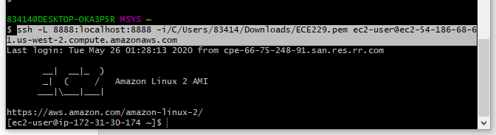

1. export JUPYTER_TOKEN=abc (set jupyter token as abc)
2. jupyter notebook --no-browser --port=8888 --ip='*' --allow-root you’ll see it

(--port=8888 --ip='*' --allow-root is part command is optional)

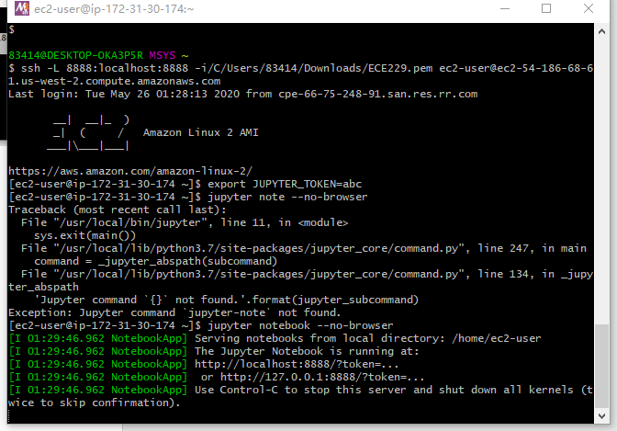

1. Tap <http://localhost:8888/tree> in your browser, then you should enter jupyter on EC2. （If you can’t, just use another port, any port like 8879, 8876, please change all commands which are involved in port）

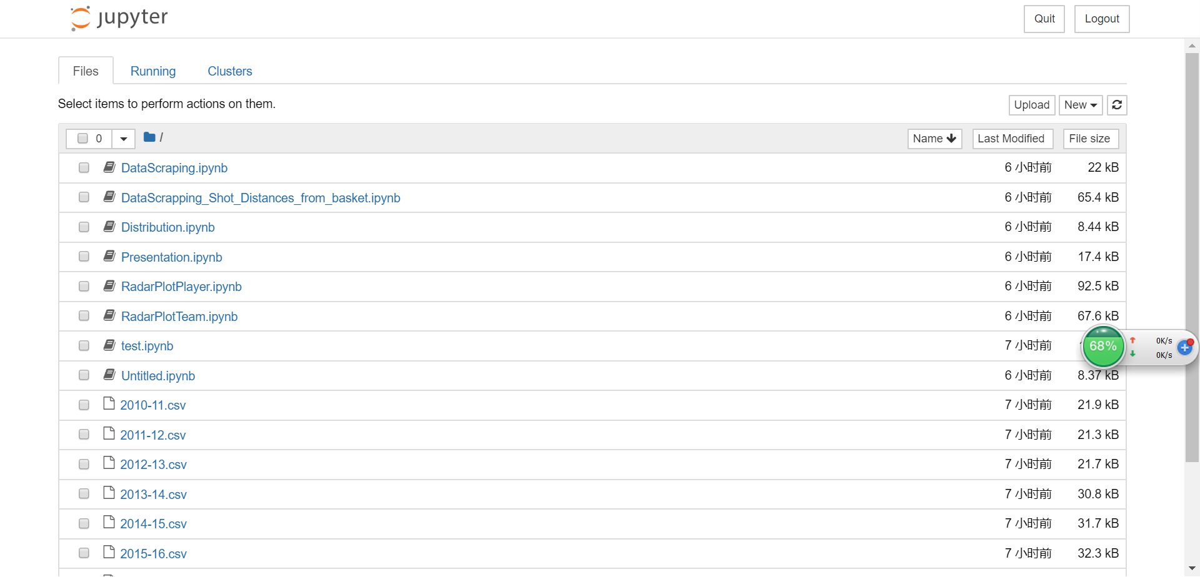

1. Now you can make edition on Jupyter Notebook

(If you need any python package, please open a new terminal, and follow the same process to enter EC2, then $ sudo python3 -m pip install numpy)

1. For presentation, please open a new terminal. This time use a different ssh command.

$ ssh -L 8866:localhost:8866 -i/C/Users/83414/Downloads/ECE229.pem [ec2-user@ec2-54-186-68-61.us-west-2.compute.amazonaws.com](mailto:ec2-user@ec2-54-186-68-61.us-west-2.compute.amazonaws.com) （Because Voila use port 8866）

Then tap $ voila Presentation.ipynb

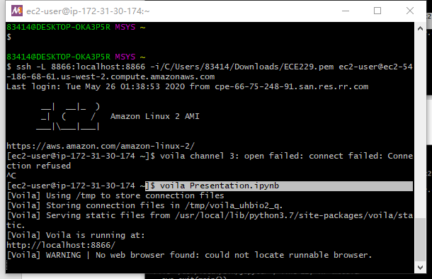

Tap <http://localhost:8866/> in your browser, then you should enter Voila.

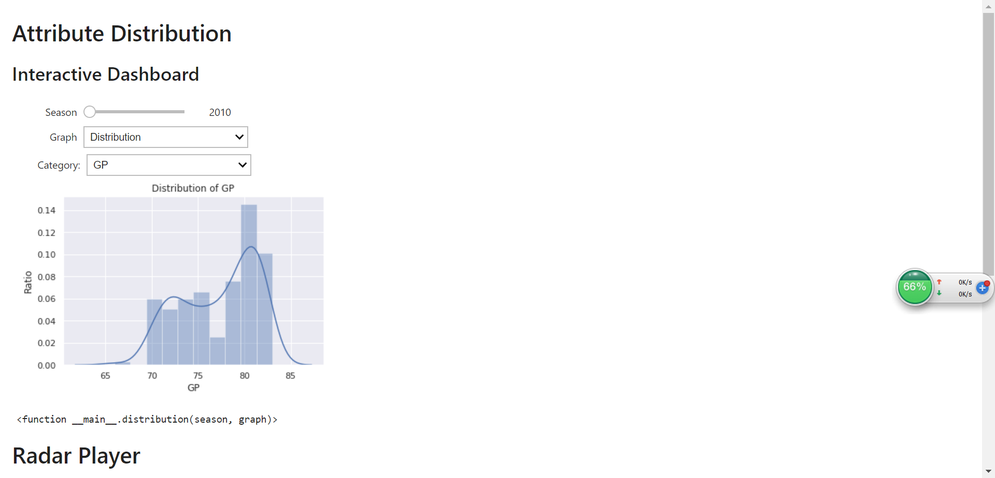

Docker

sudo yum install docker

which docker (check whether docker is installed)

sudo service docker start

sudo usermod -a -G docker ec2-user

vi Dockerfile (edit Dockerfile, vi is a editor in Linux)

docker build -t mydemo . (everytime change Dockerfile, should rebuild it)

docker run -it mydemo (docker run -p 8888:8888 mydemo)

docker ps

docker container stop 05cc70c7ba4a(CONTAINER ID)